Mary J. Mahoney

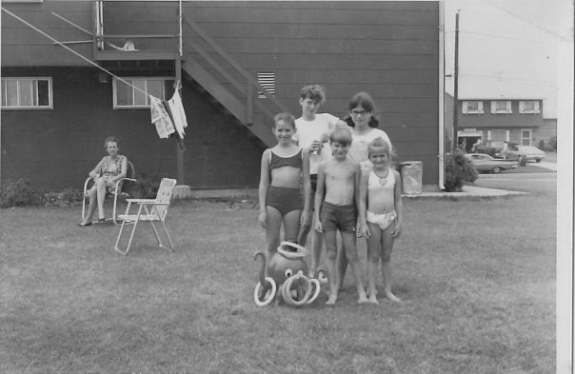

Robert Moses’ Soldiers

A Long Island Memoir

The post-war migration from New York City to the suburbs brought many young families to the new roads and neighborhoods of Long Island. We were one of those families. In the early 1960s, heading east on Long Island was the equivalent to forging west. We were pioneers of a new and exciting frontier, suburbia, made available to us by the G.I. Bill and the post-war economic boom. Citizens returning from military service were given the opportunity to chase down the American dream. They could marry, have children, and move east to the dawning Long Island suburbs of William Levitt, who built affordable mass-marketed housing developments outside of major cities, and Robert Moses, the controversial urban planner who built the rails and roads that would inscribe the dream with possibility. Families hailing from the boroughs of Brooklyn and Queens filled these new neighborhoods with joy, pride, heartache, and shared experiences. This memoir is the story of one family’s journey, from the late fifties through four decades, with a spirit that is quintessentially common for many others who, like us, partook in this great migration.

